P1 ­ Test a Perceptual Phenomenon

## What is our independent variable? What is our dependent variable?

The dependent variable is the recorded time and the independent variable is the pair type shown in the test, which is either true in the congruent condition or not in the incongruent condition.

## What is an appropriate set of hypotheses for this task? What kind of statistical test do you expect to perform? Justify your choices.

The test should be evaluated by investigating the following hypothesis:

H0 : The recorded time is either equal or higher in the congruent group compared to the incongruent group

HA : The recorded time is lower for those that saw the congruent word-color pairs.

Or:

H0 : μcongruent ≥ μincongruent

HA : μcongruent < μincongruent

I would expect to perform a negative one­tailed t­test as there are no population values but samples values that need to be compared. The z­score should not be used as the sample size is below 30 and the population standard deviation is unknown. We assume that the distributions are Gaussian[1].

We expect the recorded time to be lower if the word and color are congruent so it is a one­tailed test and we expect a smaller value for the congruent group as the time should be decreasing. The study is a one tailed dependent samples t­test.

## Report some descriptive statistics regarding this dataset. Include at least one measure of central tendency and at least one measure of variability.

|  |  |  |
| --- | --- | --- |
|  | Congruent | Incongruent |
| N | 24 | 24 |
| Minimum | 8,63 | 15,69 |
| Percentil-25 | 11,90 | 18,72 |
| Median | 14,36 | 21,02 |
| Average | 16,20 | 24,05 |
| Percentil-75 | 18,03 | 22,02 |
| Maximum | 22,33 | 35,26 |
| Variance | 12,67 | 23,01 |
| Standard-Deviation | 3,48 | 4,70 |

## Provide one or two visualizations that show the distribution of the sample data. Write one or two sentences noting what you observe about the plot or plots.

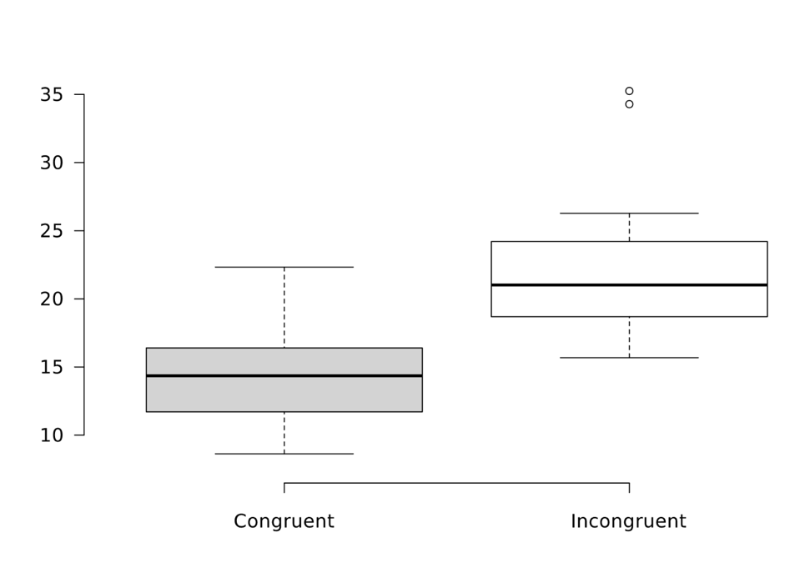[2]

Figure 1- Boxplots of congruent and incongruent samples

To compare the distributions of congruent vs. incongruent data I chose boxplots created using an online tool. For the congruent sample the median it takes to name the samples is 14.36 minutes while it takes 21.02 for participants in the incongruent sample.

## Now, perform the statistical test and report your results. What is your confidence level and your critical statistic value? Do you reject the null hypothesis or fail to reject it? Come to a conclusion in terms of the experiment task. Did the results match up with your expectations?

|  |  |
| --- | --- |
| Standard Error | 1,194 |
| df | 46 |
| t-critical | 3,496 |
| t-statistic | 6,577 |
| CI | 0,999 |
| r2 | 0,485 |

The confidence level for my statistical test is 99% with a critical T­Value of 2.50. With a T-Statistic of 8.021 the null hypothesis can be rejected. We conclude that the recorded time is lower for those that saw the congruent word colour pairs, which matches my expectations as it was easier for me to match the congruent word colour pairs.

1. http://www.statisticshowto.com/when­to­use­a­t­score­vs­z­score
2. created from dataset using http://boxplot.tyerslab.com/